SHREYA PANCHAL

1.List three popular apps you use (like Instagram, Zomato, or Spotify) and for each, identify whether it is most similar to IaaS, PaaS, or SaaS. Briefly explain your reasoning for each choice.
Answer:
App | Cloud Model | Reason
Gmail | SaaS | Users access email through a browser without managing servers.
Google App Engine | PaaS | Developers deploy applications without managing infrastructure.
AWS EC2 | IaaS | Users create and manage virtual machines, storage, and networking.

2.Create a table comparing IaaS, PaaS, and SaaS with at least three points for each model, using real-world examples such as AWS EC2, Google App Engine, and Office 365.
Answer:
Feature | IaaS | PaaS | SaaS
Control | Full control over OS and applications | Control over applications only | No infrastructure control
Managed By | User manages OS and software | Provider manages OS | Provider manages everything
Example | AWS EC2 | Google App Engine | Microsoft Office 365

3. Sign up for a free AWS account (or use an existing one), navigate to the EC2 dashboard, and launch a new t2.micro EC2 instance running Ubuntu 22.04. Take a screenshot of your running instance in the AWS console.<br><br><em><strong>Hint:</strong> Use the 'Launch Instance' button and select the free tier eligible Ubuntu AMI.</em>
Answer: Ec2 create Steps

- Login AWS Console.
- Open EC2 Dashboard.
- Click Launch Instance.
- Name: Ubuntu-Server
- Select Ubuntu Server 22.04 LTS.
- Instance Type → t2.micro
- Create New Key Pair (.pem download)
- Allow SSH (Port 22).
- Launch Instance.
- Wait until Running.
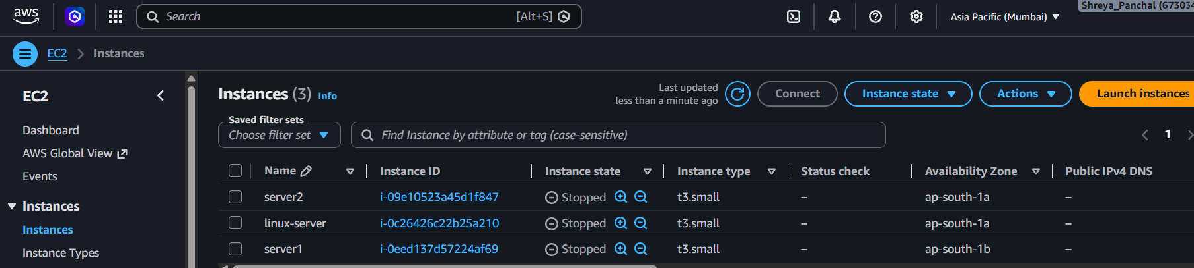
4.After your EC2 instance is running, connect to it using SSH from your local terminal or an online SSH client. Run the command 'uname -a' and note the output.<br><br><em><strong>Hint:</strong> You may need to use the .pem key file downloaded during instance setup.</em>
Answer:
Step 1: Open the EC2 Dashboard
- In the AWS Console, search for EC2.
- Click on EC2 to open the EC2 Dashboard.
- From the left menu, click on Instances.
Step 2: Select the Ubuntu EC2 Instance
- Locate your running Ubuntu EC2 instance.
- Ensure that the Instance State is Running.
- Select the instance by clicking the checkbox next to it.
Step 3: Connect to the Instance
- Click the Connect button at the top of the page.
- Select the EC2 Instance Connect tab.
- Click the Connect button again.
A browser-based terminal will open and you will be logged into the Ubuntu server.
Step 4: Execute the Command
Type the following command in the terminal:
#uname -a
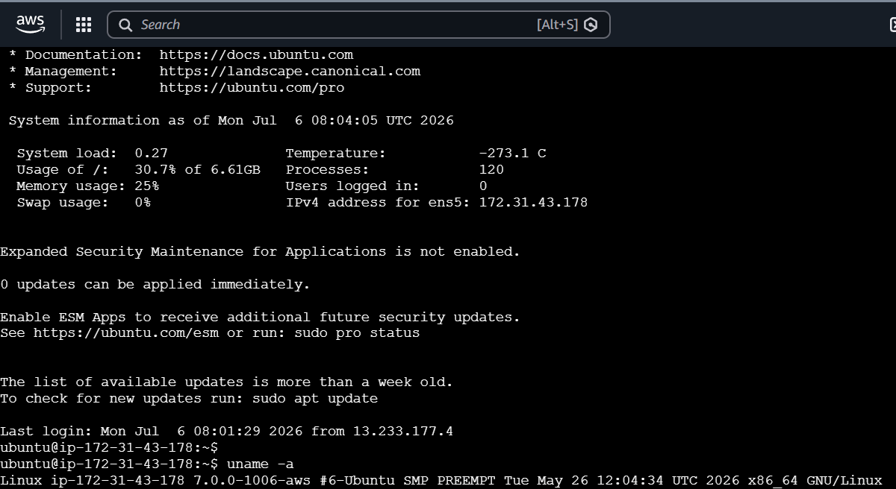

5.Suppose you want to host a simple static website for your college fest using your EC2 instance. List the basic steps you would follow after launching the instance to make your site accessible to everyone. Write 3-5 steps in order.
Answer:
- Launch an Ubuntu EC2 instance and make sure it is in the Running state.
- Connect to the EC2 instance using SSH and install a web server such as Apache (sudo apt update and sudo apt install apache2 -y).
- Upload or copy the static website files (HTML, CSS, JavaScript) to the web server directory, usually /var/www/html.
- Configure the Security Group to allow HTTP (Port 80) traffic from Anywhere (0.0.0.0/0) so the website can be accessed publicly.
- Open the EC2 Public IP or Public DNS in a web browser to verify that the website is accessible to everyone.
Result: The static website is successfully hosted on the EC2 instance and can be accessed by anyone using the Public IP or Public DNS.

